**Animal Collision Avoidance System (ACAS)**

**Introducing the problem**

15 000 large animal roadkills occur every year in Hungary, which is approximately 8 times more than pedestrian hits in a year. These accidents cause injuries and on average $2000 worth of damage to property. Our system aims to reduce the number of collisions by detecting near road animals in time to allow for deceleration and emergency braking.

Most modern cars are equipped with pedestrian detection systems, like the “Multi Purpose Camera” of Bosch, which triggers emergency braking upon a detected obstacle in the way. But it is not suitable for wildlife detection, especially at country road speeds because it was developed mainly for urban environments.

Detecting fast moving animals in a forest is a hard task not just for a human driver but also for traditional cameras or sensors like radars, especially at night or in bad weather conditions. Our plan is to deploy infrared cameras because it can sense the emitted heat of the animals, which has a great contrast to its environment.

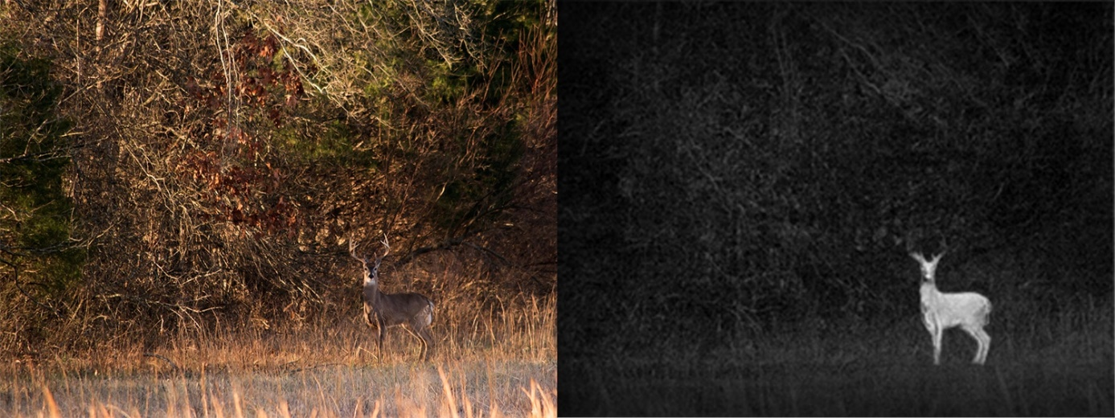

One camera is not enough, because it can not safely determine the exact position and velocity of the animal, so we decided to use two cameras, which makes it possible to use triangulation to calculate the distance of the detected animal. A great advantage of the two-camera system over the one is that it reduces measurement inaccuracy and false positive detections.

Based on the position and current speed of the animal we can calculate the probability of a collision. If this probability is high our system intervenes. It alerts the driver and decelerates the car to a safer speed. Our system complements the Bosch “Multi Purpose Camera”, because at that slower speed the Bosch camera can detect the animal if it actually does jump on the road and can trigger the emergency braking system.

The project also focuses on sustainability. On one hand it protects the wildlife, which is ever more important in todays industrialized world. On the other hand, it decreases waste production as it saves many parts of the car from being destroyed in a crash.

**The Hardware**

When planning the hardware, we tried to follow the Sense-Think-Act guidelines of Bosch engineering. This concept allows us to build a powerful, safe, and transparent hardware design containing all the necessary elements of the ACAS (Animal Collision Avoidance System).

**Sensing**

The key components of the system are the two infra cameras. The main difficulty of detecting animals in the dark forest is obvious: normal cameras working with visible light spectrum are not able to detect the danger, nor is the driver, as animals tend to hide between the trees and plants, making them nearly invisible from greater distances, especially in the dark. Heat cameras detecting the mid-infrared spectrum can easily locate animals, as they are mostly much warmer than their environment.

The optics and detectors of the cameras are elaborated in the Camera section.

The cameras are placed into the top left and right corners of the windscreen. This way, the cameras are kept safe from environmental effects like dust, rain, and temperature gradients. The small cameras don’t affect the driver, but the relatively large distance between the cameras allow the system to use distance measuring algorithms more precisely. The cameras are built onto SoC chips, which are put into a plastic housing covering the cameras and keeping them safe. The SoC chips perform some preprocessing work on the frames captured and compress them to allow data transfer via the MOST interface with 150 Mbps maximal bandwidth.

**Thinking**

Further image processing, classifying and information transfer is done in the ECU of the ACAS. Due to the high number of calculations performed, the system requires an own, dedicated ECU to work, which is placed under the wipers at the back of the engine bay. Many car manufacturers place ECUs here, so this position can be used for such applications in almost every car, therefore it is quite a universal solution.

The components of the ECU perform diverse tasks. The majority of the calculations are done by the GPU. Since it can perform a high number of calculations in a short period of time, it is optimal for image processing.

This produces a lot of heat which must be withdrawn from the ECU. The aluminum housing of the ECU is therefore equipped with a heat sink and a cooling fan. The fan is regulated with the cooling control IC. The ECU has to operate without interruption in the temperature range of -30°C to 80°C. More extreme temperatures have a very low possibility, the broadening of the temperature range would make the system too expensive.

The processor of the ECU regulates every process, it loads the source code from the EEPROM, transfers the video input to the GPU and communicates with the other systems of the ACAS via the outputs. A further essential component is the memory, which stores the runtime data required by the image processing program. The main inputs of the ECU are the MOST interface cables coming from the cameras transferring the video captured by the two infrared cameras. Another input is the vehicle dynamics, containing information about the speed, acceleration, and direction of the car. This is connected to the ECU with CAN-FD cables. This information is necessary to compute the trajectory of the car, and the estimate crash probability with the animal.

Outputs from the ECU run via CAN-FD cables as well, as these are only commands which do not require high bandwidth. One of the cables run to the Vehicle Control Unit, transferring the “decelerate vehicle” command. Two cables go into the cockpit of the car to control the warning signals and the sounds.

The energy required for every component is supplied by the 12/24V DC system of the car. To save the components from shorts, the energy supply system is equipped with Transient Protection and Reverse Battery Protection as well. A further EMI filter modul is built into the power supply system to suppress harmful electromagnetic interference. The cameras run with 12V DC, the ECU with 5V DC. These voltages levels are set with DC-DC converters supplying the systems directly with the required voltage. For uninterrupted power, both the cameras and the ECU are equipped with backup capacitors to supply energy in case of a short (<1s) power failure. Capacity values required are around 47mF, with the aging of the components also taken into consideration.

**Acting**

If an animal is within the “danger zone”, the area from which the animal can enter the road in a way that it can lead to collisions, a deceleration command is transferred to the Vehicle Control Unit. This lowers the speed of the vehicle to a speed at which the Multi-Purpose Camera built into the middle of the windscreen takes over and if necessary, carries out an emergency braking. The information about the animals is also transmitted into the cockpit, where warning lights and sound signals alert the driver of the hazard.

The exact form of driver alerting depends on the possibilities in the car. If the car is equipped with a Head-Up-Display, the danger signal appears on the windscreen, asking the driver to drive slower and more attentive. (Braking is only carried out if the animal is possibly going to crash into the car, but the simple presence of animals next to the road in dangerous positions also requires slowing down. The exact driver-alerting mechanism is elaborated in the Decision section.) Many cars nowadays are equipped with ambient lighting. If so, the ambient lights can turn on and start blinking in red at the side of the car where the animal is coming from. The cockpit display/monitor can stream the video captured by the infrared camera to help the driver locate the animal in the dark forest. Further warning sound signals can alert the driver.

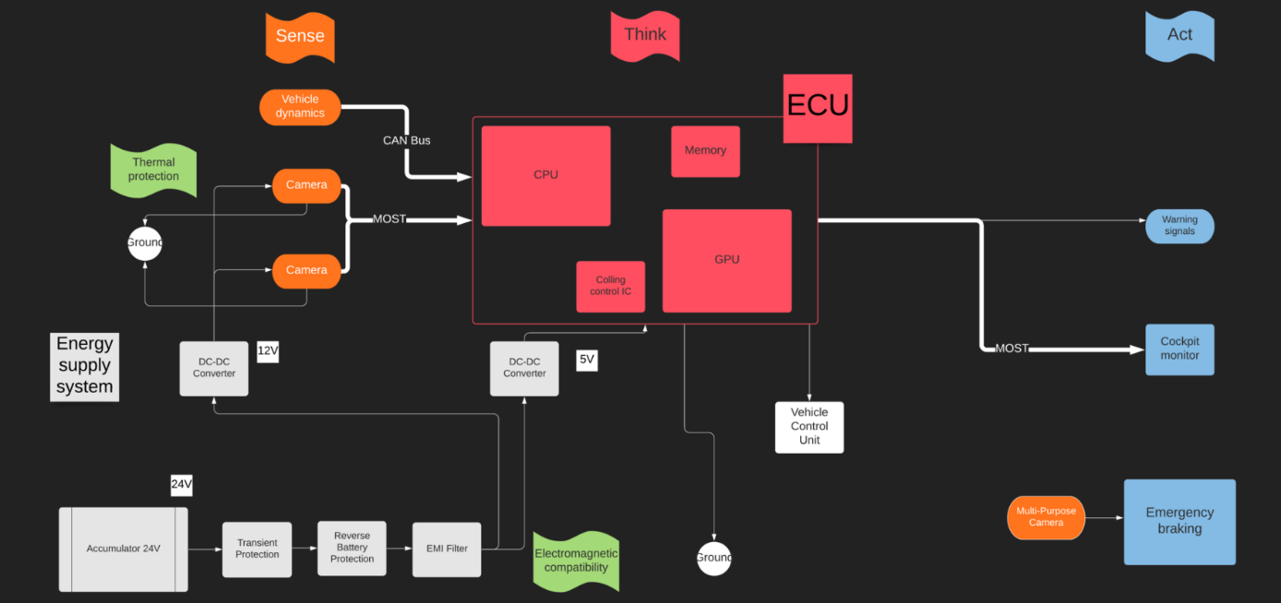

**The camera-system**

**Fundamental idea**

We want to notice animals in their natural environment. It can be difficult for two reasons: first is, that we can meet them not only on roads, which goes through fields, but also on forest roads; the second is that animals move mainly at night. In both cases human vision is not able to notice animals, so the driver can not react before the accident. The normal RGB cameras with AI can recognise objects in ideal urban circumstances, but they are not able to notice wild animals with natural camouflage because they move fast, they are “invisible” for these cameras in a bushy forest or at night. The reflectors of the vehicle provide solution to see animals at night, but they only light up the road, so the approaching animals won’t be perceived. Our detection is based on thermal radiation. Large mammals (for example deer, roe, boar and also human) have a radiation in the near infrared interval (800 nm – 2500 nm), that is outside of the visible spectrum (380 nm – 780 nm). With this type of radiation, animals can be perfectly detectable for NIR-cameras. Surrounding objects have a significantly lower thermal radiation, thus providing a good contrast.

**Structure**

Our camera-system has two cameras. The cooperation of these cameras support the Bosch “Multi Purpose Camera”. We can use our innovation for the “multipath approach” function. (“The benefits of this multipath approach are particularly apparent in real, complex traffic situations. The camera navigates by lines on the asphalt, by other characteristics indicative of a road surface, such as gravel, parked vehicles at the side of the road, and safety barriers. **With this, the reliability of automatic emergency braking systems increases, particularly in chaotic urban traffic, as the multi purpose camera can detect and classify partially obscured pedestrians and cyclists.**” - <https://www.bosch-mobility-solutions.com/en/solutions/camera/multi-purpose-camera/>)

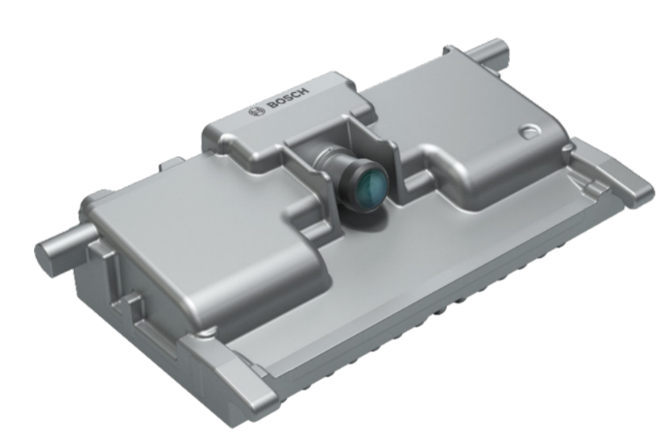Optics: Horizontal field of view: ±50°

Vertical field of view: 27°up, 21°down

Aperture: F1.8

Imager: Resolution: 2048 x 1280 pixels

Color pattern: RCCG

Frame rate: 45 fps

Mechanics: Box size: 120 x 61 x 36 mm

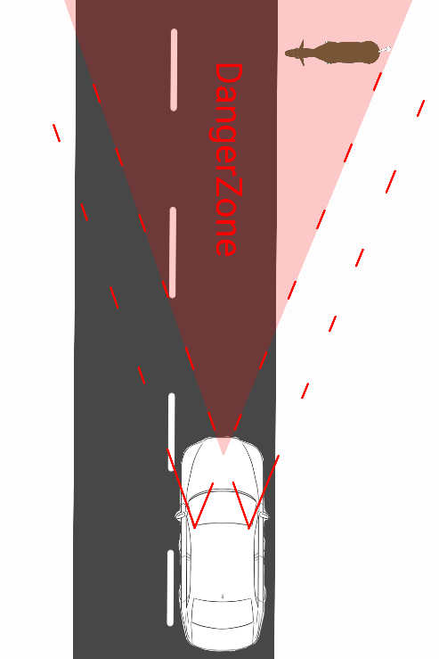**Measurement and field of view**

We would like to extend this multipath approach task to country roads to avoid the accident with animals. The two NIR-cameras must detect the large mammal on, at the side, or in the forest close to the road. The other important task of the NIR-cameras is to determine the distance and calculate the speed and direction of the noticed animal. Because of this second function, we must use 2 cameras to evolve this kind of 3D-vision.

The next figures and formulas show our method:

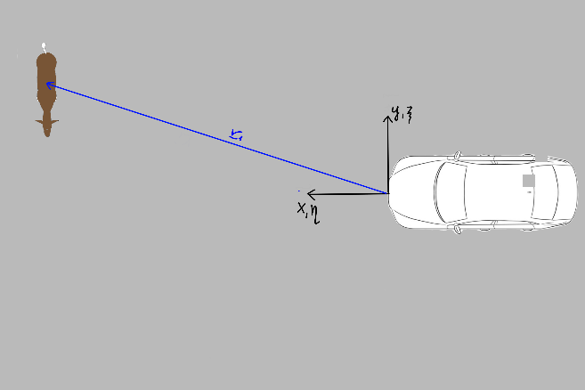Calculating the velocity of the animal:

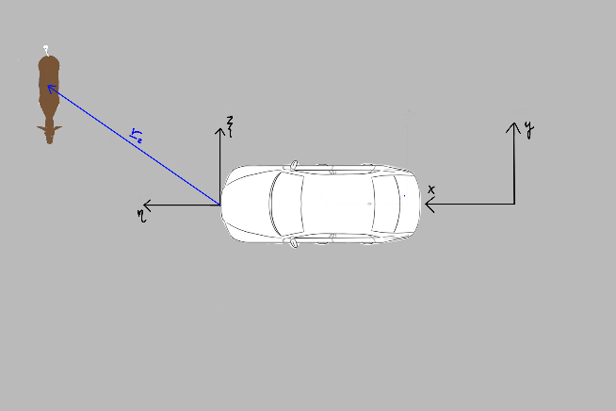

The field of view of the cameras must be large enough, because the areas further away from the side of the road are the most important for us to detect animals as soon as possible. The effective zone in distance and velocity measure is, where both cameras have detection area. The danger zone is the area from which animals running at full speed (approximately 50 km/h) perpendicular to the car (approximately 90 km/h) can crash into it. The angle of this area from the front of the car is . The effective zone of view of the cameras has been chosen to match this angle.

**Optics**

An example to this type of NIR-lense: 3.5mm C Series VIS-NIR Fixed Focal Length Lens Field of view at max sensor format:

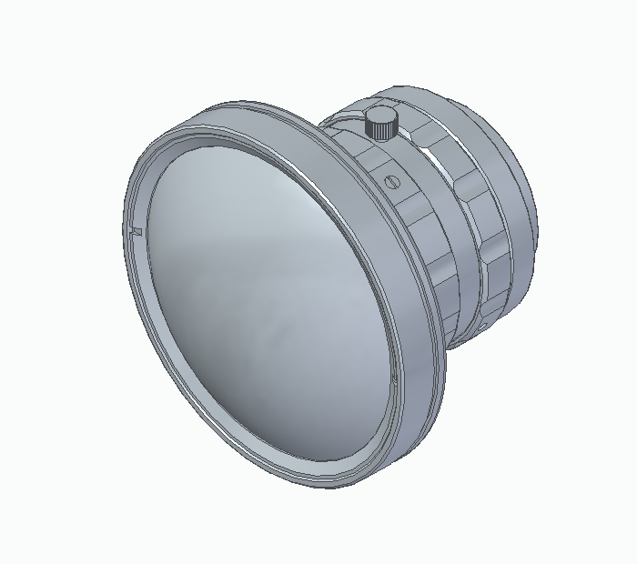Horizontal: 102,4°

Vertical: 82,3°

Size: 33 x 40 x 33 mm

**Detector**

We need a camera, that detects in NIR spectrum. It must have enough large resolution, sensing area and pixel depth with small pixel size to be able to provide sufficient information about the image. The camera is built onto a SoC (System on Chip) architecture. The chip performs preprocessing on the raw picture and compresses it to enable data transfer via the MOST interface (max. 150 Mbps). This way the whole camera has a compact design which saves space in the car and does not disturb the drivers view. This quantity of data allows that the image processor (after a properly set noise filtering) creates a sharp and accurate image about the objects of which thermal radiation is in the searched interval.

**An example to this type of camera with the appropriate sensor:**

**Camera: Allied Vision 1800 U-501m NIR**

Pixels (H x V): 2592 x 1944

Pixel Depth: 8/10 bit

Resolution: 5 (MegaPixels)

Pixel Size, H x V (µm): 2,2 x 2,2

Frame Rate: 68 fps

Operating Temperature: -30°C – 80°C

Size: 38 x 29 x 29 mm

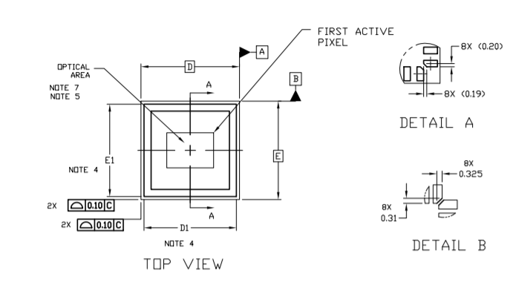**Imaging Sensor: ON Semi AR0522**

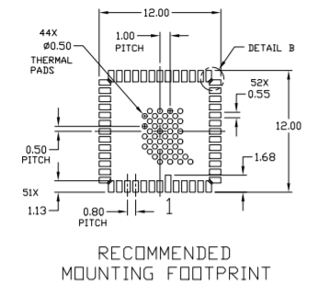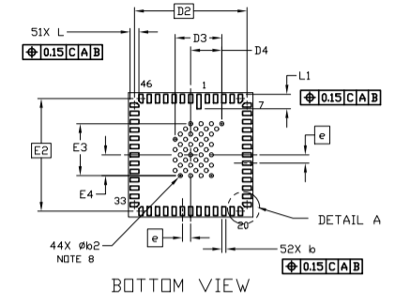

**Decision-making algorithm**

The decision-making algorithm of the system is essential to ensure safe working. The algorithm decides how to interact based on the environment conditions and the exact position and movement of the animals.

If the system is active, the infrared cameras scan the environment of the car without interruption to detect wild animals. The AI system running in the ECU is able to differentiate between diverse sources of heat, like humans, small animals (birds, cats, etc.), and other cars. If only one camera sees an animal, it is outside the danger zone. In this case, the probability of crash is significantly low. In this case, the system won’t interact in any way.

If the animal is in the danger zone, the system calculates whether there is a possibility of crash. The system uses the dynamics data of the car and the calculated trajectory of the animal to check the chance for collision. If collision is not possible, for example the animal only stands next to the road, the system informs the driver of the potential hazard by a short sound signal and an animal warning message appearing on the dashboard. The videos captured by the cameras are streamed to the main infotainment screen, so that the driver can more easily locate the animal with the heat camera pictures. If collision is probable, the car automatically starts braking until the car reaches about 50 km/h.

The reason for only braking until 50 km/h is that under that speed, the urban pedestrian/cyclist collision avoidance system is activated in cars equipped with Bosch Multi-Purpose Camera. If this system detects a possible crash with an object jumping in front of the car, it performs emergency braking. So, the decision of emergency braking is given to the more advanced Multi-Purpose Camera System, while the infra cameras support this by slowing down to the appropriate speed and detecting animals way before the classic cameras could see them.

If the car is slowed down and the animals jumps in front of the car, the car performs emergency braking. Otherwise, the driver is alerted more heavily than before, by infotainment-screen video, flashing lights, sound signals and potentially via the Head-Up Display. (For more details, see the Hardware section).

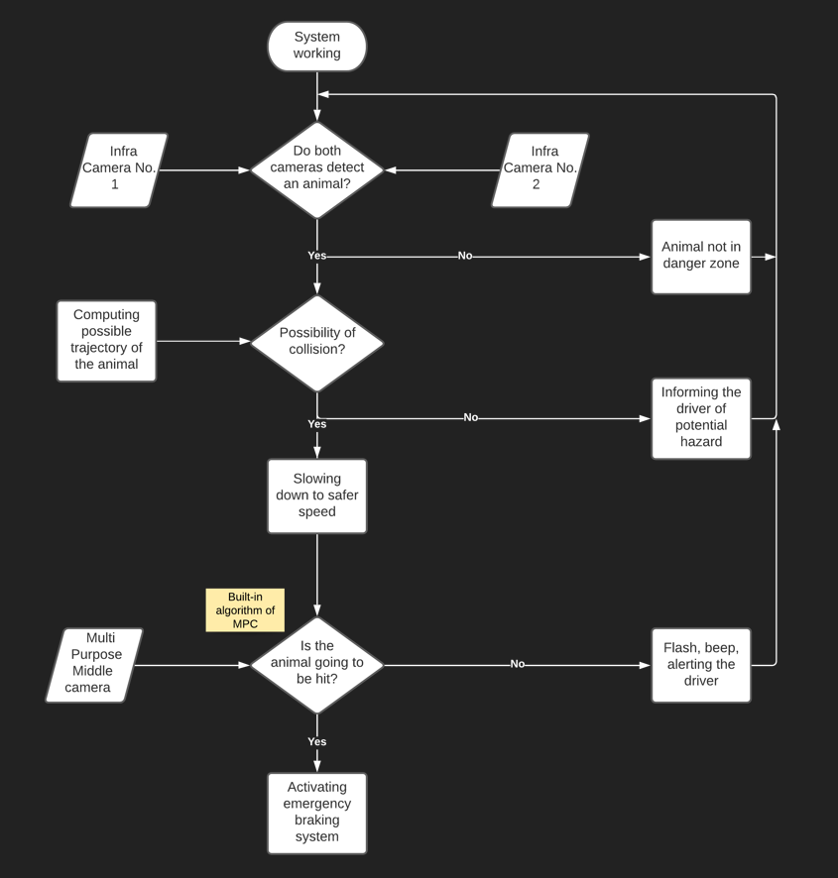

**The Software**

Beside the hardware the project also needs a strong software part. The most important is to detect and recognize the animal. It is not a simple task because of the noise in picture and the obstacles between the car and the animal. It requires advanced computer vision algorithms and a well-performing AI. It is important to make a difference between animals and other vehicles on the road, or static heat sources next to the road. It is important to decide based on multiple pictures, to filter out noise and false positive cases.

The usage of multiple cameras allows us to triangulate the exact position of the animal, which is way more accurate, than only using one image and the displacements in it. By knowing the velocity of the vehicle, we can also calculate the moving direction and speed of the animal and based on that information we can estimate the chance of a possible collision and make the right decision.